Keystone Library
CONNOR LANGSFORD

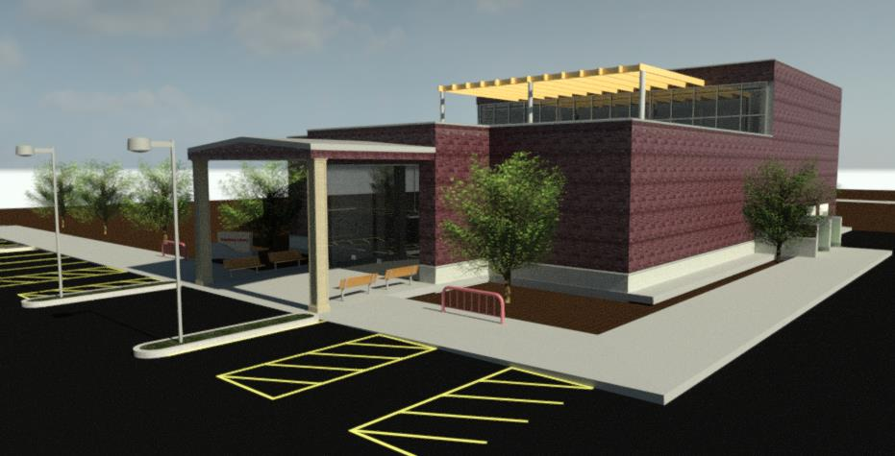
Keystone Library
Connor Langsford
2/21/25
Abstract
Design documents of the creation of a Library in Noblesville, IN
Table of Contents
Description: | Page Number(s)
Project Description | 2
Building Code and Regulations | 3-5
Composite Floor Load-Span table | 6
Roof Load | 7
Beam Calculations | 8-19
Spread Footing | 20-21
Wastewater Discharge | 22
Framing | 23
First Floor Plan | 24
Second Floor Plan | 25
Elevation Views | 26
Section Views | 27
Landscaping | 28
Site Plan | 29
Schedules | 30

Project Description
-Overview
Design of the redevelopment of an existing industrial brownfield site in Noblesville, IN.
-Criteria and Constraints
- A safe and efficient building with adequate utilities and services
- parking with desirable traffic flow
- storm water management
- modern entryway and vestibule
- accessibility
- exterior covered area with benches
- Elevator must be added
- One Low Impact Development technique
- Entry and Circulation Desk area
- Children’s Help Desk
- Open area for stacks and computer terminals on both floors
- Public restroom on both floors
- Head Librarian’s office
- Staff workroom/ kitchenette
- Staff restroom
- Two meeting rooms
- Noblesville History room
- Mechanical room
- Books out of direct sunlight
- Green roof with walkway
- Trash receptacle

Building Code and Regulations
-Building Type
This library is public so it will be a type one construction using non - combustible materials. (Reference IBC, chapters 5-6)
-Occupancy
Group A – 3 assembly (Reference IBC, chapter 3)
-Egress
Must meet Egress requirements for an A – 3 building (Reference IBC, chapter 10)
- Number of exits: 2 per story (Reference IBC, Table 1021.1)
- Width of exits: 0.3in stairway per occupant, 0.2in door per occupant (Reference IBC, Section 3412.6.11)
$$Stairway width=0.3in × 194 people$$
$$Stairway width=58.2in$$
$$Door width=0.2in × 194 people$$
$$Door width=38.8in$$
-Climate Zone
Zone 5A, cold and moist (Reference Energy Conservation Code)
-Zoning
B: Commercial District (Reference NUDO, Article 7)
- Minimum Lot Size
3 acers (Reference FUDO)
-Maximum Building Hight
35ft (Reference FUDO)
-Roof Live Load
20psf but will be adjusted based on snow load calculations (Reference IBC, chapter 16, section 1607)
-Parking Lot
- Ninety-degree (90º) angle space: Twenty-four-foot (24’) wide parking aisle for one- or two-way traffic, 3ft wide one-way sidewalk, 5ft wide two-way sidewalk (Reference, FUDO)
- Driveway Width must be at least 10ft but no more than 24ft wide.
- Lights shall not excide 35ft tall (Reference, FUDO), constant throughout property
- One space per 3 people (Reference FUDO)
Reading Area = 50sqft * person
Stack Area = 100sqft * person
Meeting Rooms = 15sqft * person
Office Space = 150sqft * person
$$Max Occupancy= \frac{Library Area (sqft)}{Occupant Load Factor (sqft*person)}$$
$$Reading Area= \frac{6120sqft}{50sqft*person}$$
$$Reading Area= 122 people$$
$$Stack Area= \frac{4320sqft}{100sqft*person}$$
$$Stack Area= 43 people$$
$$Meeting Rooms= \frac{360sqft}{15sqft*person}$$
$$Meeting Rooms= 24people$$
$$Office Space= \frac{720sqft}{150sqft*person}$$
$$Office Space= 5 people$$
$$Total Max Occupancy=194 people$$
$$Number of Parking Spaces= \frac{Max Occupancy}{3}$$
$Number of Parking Spaces=$65 spaces
- 51 to 75 spaces need at least 3 accessible parking spaces (Reference IBC, Table 1106.1)
- Loading berths and areas shall be provided
- Screening shall be a ten-foot (10’) wide landscaped buffer with One evergreen tree planted every eight (8) feet; and one shrub planted every twelve (12) feet; and one deciduous tree planted every fifteen (15) feet along the perimeter of the outdoor sales or outdoor display area (Reference FUDO)
- Each island or peninsula shall be at least one hundred eighty (180) square feet in size. 3. Each island or peninsula shall contain at least one (1) tree per one hundred eighty (180) square feet. (Reference FUDO)
- Minimum thirty-foot (30’) buffer yard (Reference FUDO)
- Designed such that there will be no increase in the peak discharge runoff rate as a result of the proposed development (Reference FUDO)
- 10 to 99 spaces need 5% to be landscaped (Reference FUDO)
- Set back of 8ft from all buildings (Reference FUDO)

Composite Floor Load-Span table
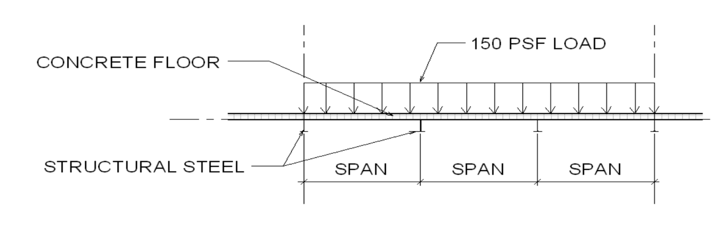
Roof Load
-Live Load
20psf (Reference IBC 1607.11)
-Dead Load
Steel Joist 10psf, Plaster ceiling 10psf
-Snow Load
$P_{s}=0.7C_{s}C_{e}C_{t}I_{s}P_{g}$
$P_{s}=0.7(1)(1)(1.1)(1.1)(20psf)$
$P_{s}=16.94psf$
$P_{s}≥I_{s}P_{g}$
$16.94 ≥(1.1)(20psf)$
$16.94 ≥22sf$
$P_{s}=22psf$
-Total Roof Design Load
$62psf$
Beam Calculations
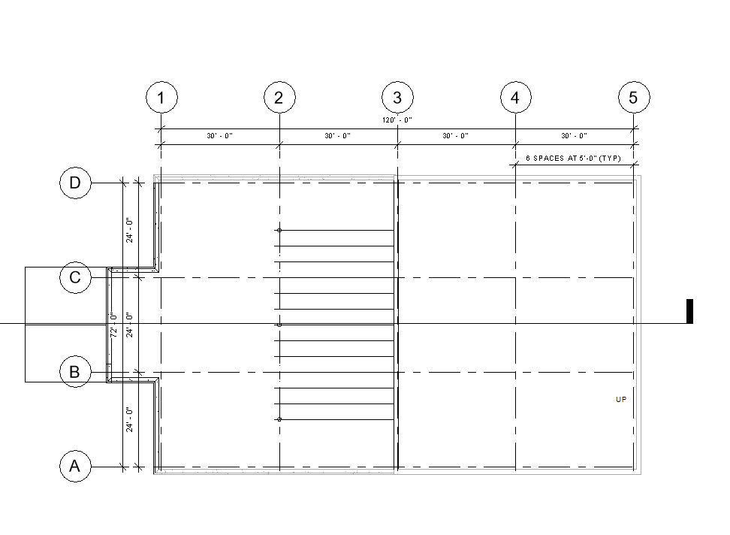
Dead Load = Roofing 62psf + mechanicals 3psf
(Reference IBS section 1606)
Live Load = stack room ${150}^{b}psf$ (Reference IBS section 1607.1)
Total Load = 215psf
$$F_{y}=50 ksi$$
$$E = 29,000 ksi$$
-Interior Beam
- Diagram
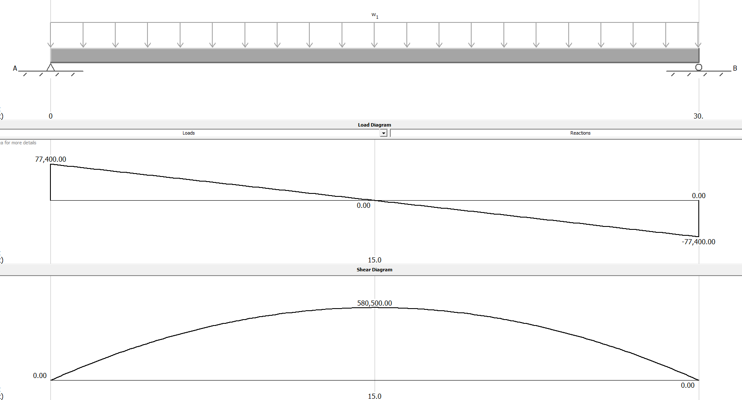
- Calculation
$$w= Total loads psf × Tributary Width ft$$
$$w= 215psf × 24ft$$
$$w=5160plf$$
$$R_{a/b}= \frac{wL}{2}$$
$$R_{a/b}= \frac{(5160plf)(30ft)}{2}$$

$R_{a/b}= 77400$lb
$$M_{max}= \frac{wL^{2}}{8}$$
$$M_{max}= \frac{(5160lb)({30ft)}^{2}}{8}$$
$M_{max}= 580500$lb*ft
$$M_{n} ≥ M_{a}× Ω_{b}$$
$$M_{n} ≥(580500lb*ft)(1.67)$$
$$M_{n} ≥ 969435lb*ft$$
$$M_{n}= F_{y} × Z_{x}$$
$$Z_{x}= \frac{M_{n}}{F_{y}}$$
$$Z_{x}= \frac{969435lb*ft}{50000psi} × \frac{12ft}{1in}$$
$$Z_{x}= 232.66{in}^{3}$$
w27X84
$$V_{n} ≥ V_{a} × Ω_{v}$$
$$V_{n} ≥(77400lb)(1.5)$$
$V_{n} ≥ 116100$lb
$$V_{n}=0.6 × F_{y} × d × t_{w}$$
$$V_{n}=0.6(50000psi)(26.71in)(0.46in)$$
$$V_{n}=368598lb$$
$368598lb ≥116100$lb
$$∆_{max}= \frac{5wL^{4}}{384EI}$$
$$∆_{max}= \frac{5(5160plf × \frac{1in}{12ft}){(30ft × \frac{12in}{1ft})}^{4}}{384(29000000psi)(2850{in}^{4})}$$
$$∆_{max}= 1.14in$$
$$\frac{L}{240} > ∆_{max}$$
$$\frac{(30ft × \frac{12in}{1ft})}{240} > ∆_{max}$$
$$1.5in >1.14in$$
$$\frac{L}{360} > ∆_{max}$$
$$\frac{(30ft × \frac{12in}{1ft})}{360} > ∆_{max}$$
$$1in >1.14in$$
$$w27x94$$
$$∆_{max}= \frac{5(5160plf × \frac{1in}{12ft}){(30ft × \frac{12in}{1ft})}^{4}}{384(29000000psi)(3270{in}^{4})}$$
$∆_{max}= 0.99$in
$$1 >0.99in$$
Final Design: w30x90 because it is lighter than w27x94 and stiffer, so it still meets all the requirements
-Exterior Beam
- Diagram
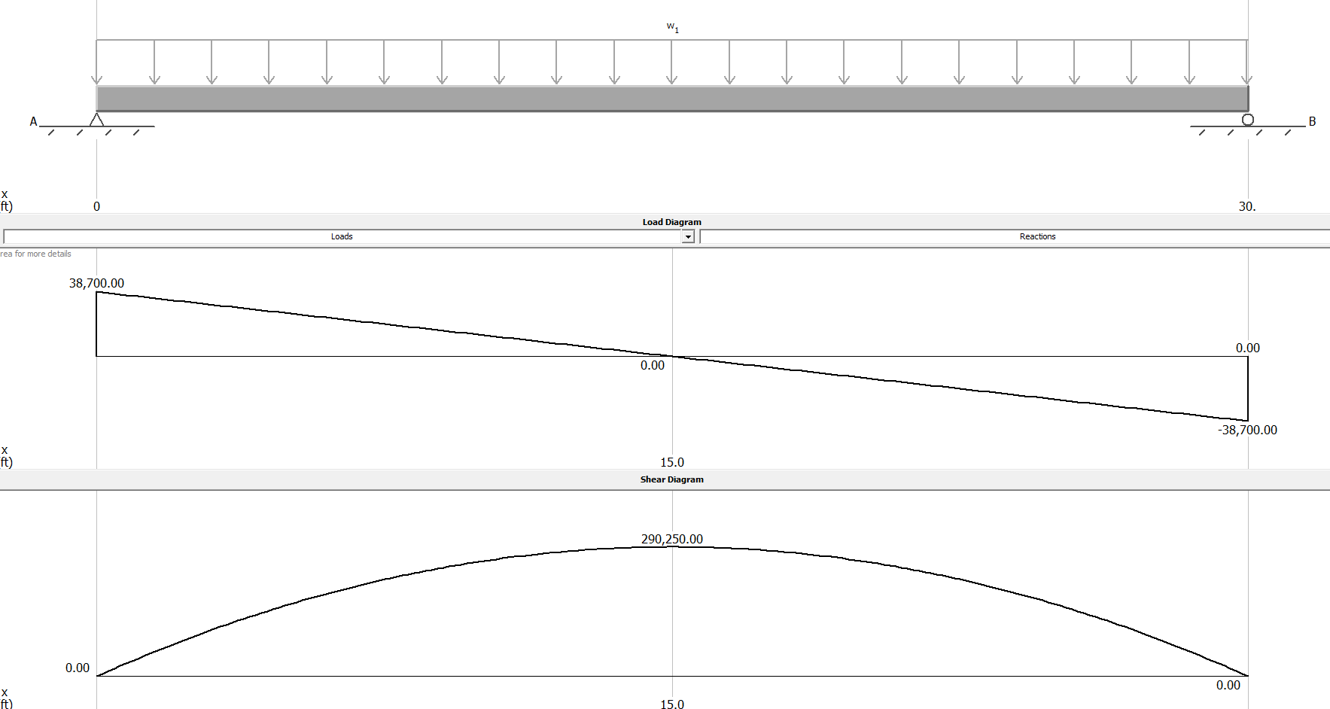
- Calculations
$$w= Total loads psf × Tributary Width ft$$
$$w= 215psf × 12ft$$
$$w=2580plf$$
$$R_{a/b}= \frac{wL}{2}$$
$$R_{a/b}= \frac{(2580plf)(30ft)}{2}$$

$R_{a/b}= 38700$lb
$$M_{max}= \frac{wL^{2}}{8}$$
$$M_{max}= \frac{(2580lb)({30ft)}^{2}}{8}$$
$M_{max}= 290250$lb*ft
$$M_{n} ≥ M_{a}× Ω_{b}$$
$$M_{n} ≥(290250lb*ft)(1.67)$$
$$M_{n} ≥ 484717.5lb*ft$$
$$M_{n}= F_{y} × Z_{x}$$
$$Z_{x}= \frac{M_{n}}{F_{y}}$$
$$Z_{x}= \frac{484717.5lb*ft}{50000psi} × \frac{12ft}{1in}$$
$$Z_{x}= 116.33{in}^{3}$$
w24x55
$$V_{n} ≥ V_{a} × Ω_{v}$$
$$V_{n} ≥(38700lb)(1.5)$$
$V_{n} ≥ 58050$lb
$$V_{n}=0.6 × F_{y} × d × t_{w}$$
$$V_{n}=0.6(50000psi)(23.57in)(0.395in)$$
$$V_{n}=279304.5lb$$
$$279304.5lb ≥58050lb$$
$$∆_{max}= \frac{5wL^{4}}{384EI}$$
$$∆_{max}= \frac{5(2580plf × \frac{1in}{12ft}){(30ft × \frac{12in}{1ft})}^{4}}{384(29000000psi)(1350{in}^{4})}$$
$$∆_{max}= 1.20in$$
$$\frac{L}{240} > ∆_{max}$$
$$\frac{(30ft × \frac{12in}{1ft})}{240} > ∆_{max}$$
$$1.5in >1.2in$$
$$\frac{L}{360} > ∆_{max}$$
$$\frac{(30ft × \frac{12in}{1ft})}{360} > ∆_{max}$$
$$1in >1.2in$$
$$w24x68$$
$$∆_{max}= \frac{5(2580plf × \frac{1in}{12ft}){(30ft × \frac{12in}{1ft})}^{4}}{384(29000000psi)(1830{in}^{4})}$$
$$∆_{max}= 0.89in$$
$$1in >0.89in$$
Final Design: w24x68
-Girder on Column line 3
- Diagram
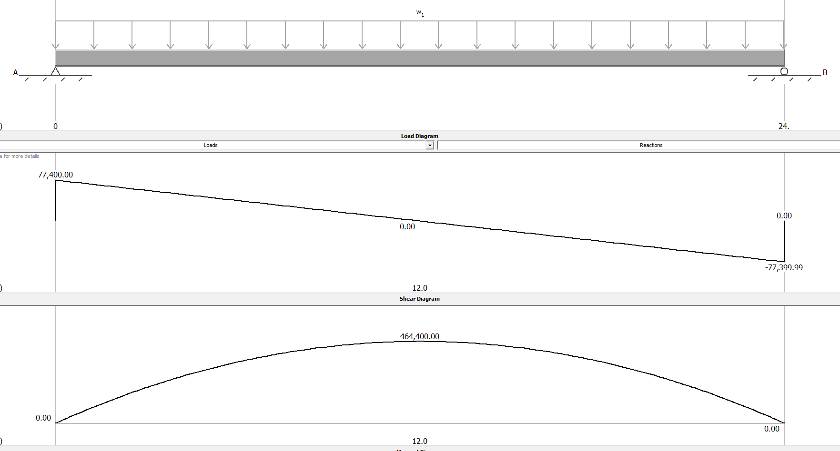
- Calculation

$$w= Total loads psf × Tributary Width ft$$
$$w= 215psf × 30ft$$
$$w=6450plf$$
$$R_{a/b}= \frac{wL}{2}$$
$$R_{a/b}= \frac{(6450plf)(24ft)}{2}$$

$R_{a/b}= 77400$lb
$$M_{max}= \frac{wL^{2}}{8}$$
$$M_{max}= \frac{(6450lb)({24ft)}^{2}}{8}$$
$M_{max}= 464400$lb*ft
$$M_{n} ≥ M_{a}× Ω_{b}$$
$$M_{n} ≥(464400lb*ft)(1.67)$$
$$M_{n} ≥ 775548lb*ft$$
$$M_{n}= F_{y} × Z_{x}$$
$$Z_{x}= \frac{M_{n}}{F_{y}}$$
$$Z_{x}= \frac{775548lb*ft}{50000psi} × \frac{12ft}{1in}$$
$$Z_{x}= 186.13{in}^{3}$$
W27x84
$$V_{n} ≥ V_{a} × Ω_{v}$$
$$V_{n} ≥(77400lb)(1.5)$$
$V_{n} ≥ 116100$lb
$$V_{n}=0.6 × F_{y} × d × t_{w}$$
$$V_{n}=0.6(50000psi)(26.71in)(0.46in)$$
$$V_{n}=368598lb$$
$$368598lb ≥116100 lb$$
$$∆_{max}= \frac{5wL^{4}}{384EI}$$
$$∆_{max}= \frac{5(6450plf × \frac{1in}{12ft}){(24ft × \frac{12in}{1ft})}^{4}}{384(29000000psi)(2850{in}^{4})}$$
$$∆_{max}= 0.58in$$
$$\frac{L}{240} > ∆_{max}$$
$$\frac{(24ft × \frac{12in}{1ft})}{240} > ∆_{max}$$
$$1.2in >0.58in$$
$$\frac{L}{360} > ∆_{max}$$
$$\frac{(24ft × \frac{12in}{1ft})}{360} > ∆_{max}$$
$$0.8in >0.58in$$
Final Design: w27x84
-Girder on Column Line 5
- Diagram
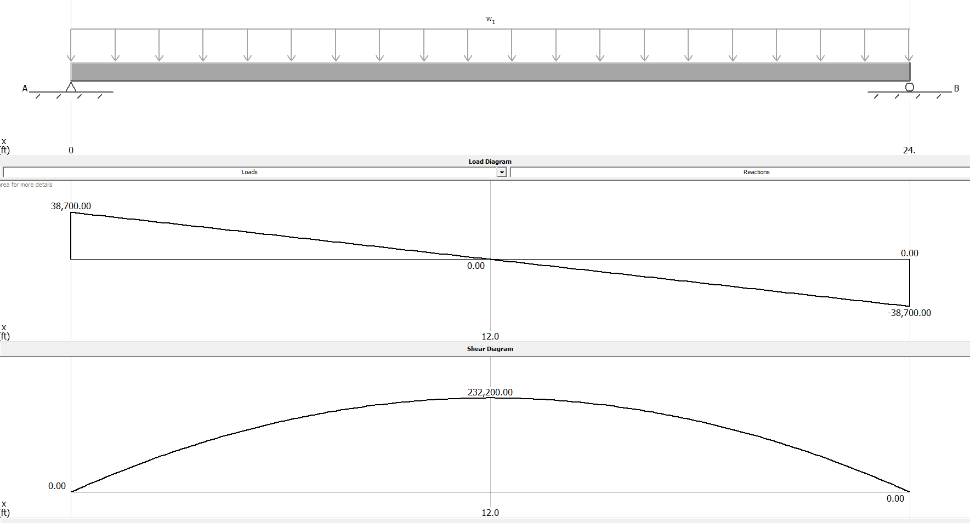
- Calculation
$$w= Total loads psf × Tributary Width ft$$
$$w= 215psf × 15ft$$
$$w=3225plf$$
$$R_{a/b}= \frac{wL}{2}$$
$$R_{a/b}= \frac{(3225plf)(24ft)}{2}$$

$R_{a/b}= 38700$lb
$$M_{max}= \frac{wL^{2}}{8}$$
$$M_{max}= \frac{(3225lb)({24ft)}^{2}}{8}$$
$M_{max}= 232200$lb*ft
$$M_{n} ≥ M_{a}× Ω_{b}$$
$$M_{n} ≥(232200lb*ft)(1.67)$$
$$M_{n} ≥ 387774lb*ft$$
$$M_{n}= F_{y} × Z_{x}$$
$$Z_{x}= \frac{M_{n}}{F_{y}}$$
$$Z_{x}= \frac{387774lb*ft}{50000psi} × \frac{12ft}{1in}$$
$$Z_{x}= 93.07{in}^{3}$$
W24x55
$$V_{n} ≥ V_{a} × Ω_{v}$$
$$V_{n} ≥(38700lb)(1.5)$$
$V_{n} ≥ 58050$lb
$$V_{n}=0.6 × F_{y} × d × t_{w}$$
$$V_{n}=0.6(50000psi)(23.57in)(0.395in)$$
$$V_{n}=279304.5lb$$
$$279304.5lb ≥58050lb$$
$$∆_{max}= \frac{5wL^{4}}{384EI}$$
$$∆_{max}= \frac{5(3225plf × \frac{1in}{12ft}){(24ft × \frac{12in}{1ft})}^{4}}{384(29000000psi)(1350{in}^{4})}$$
$$∆_{max}= 0.61in$$
$$\frac{L}{240} > ∆_{max}$$
$$\frac{(24ft × \frac{12in}{1ft})}{240} > ∆_{max}$$
$$1.2in >0.61in$$
$$\frac{L}{360} > ∆_{max}$$
$$\frac{(24ft × \frac{12in}{1ft})}{360} > ∆_{max}$$
$$0.8in >0.61in$$
Final Design: w24x55

Spread Footing
$$q_{allowable}=3500psf$$
Current Footing: 7’ x 7’ x 2.03’
-Columns on Line 2
Interior Beam End Reaction = 77400lb
Interior Girder End Reaction = 77400lb
Total load = 309600lb
$$A ≥ \frac{P}{q_{allowable}}$$
$$A ≥ \frac{309600lb}{3500psf}$$
$$A ≥ 88.46sf$$
A = 99.47sf
Footing: 7’ x 7’ x 2.03’
-Columns on Line 3
Green Roof = 309600lb
$$Roof = 62psf × 180sf$$
$$Roof = 11160lb$$
Total load = 320760lb
$$A ≥ \frac{P}{q_{allowable}}$$
$$A ≥ \frac{320760lb}{3500psf}$$
$$A ≥ 91.65sf$$
A = 99.47sf
Footing: 7’ x 7’ x 2.03’
-Columns on Line 4
Green Roof = 309600lb
$$Roof = 62psf × 720sf$$
$$Roof = 44640lb$$
Total load = 354240lb
$$A ≥ \frac{P}{q_{allowable}}$$
$$A ≥ \frac{354240lb}{3500psf}$$
$$A ≥ 101.21sf$$
A = 99.47sf
New footing = 8’ x 8’ x 2.03’

Wastewater Discharge
- Invert elevation at sewer main is 766.05ft
- 12in Pipe Diameter (1ft)

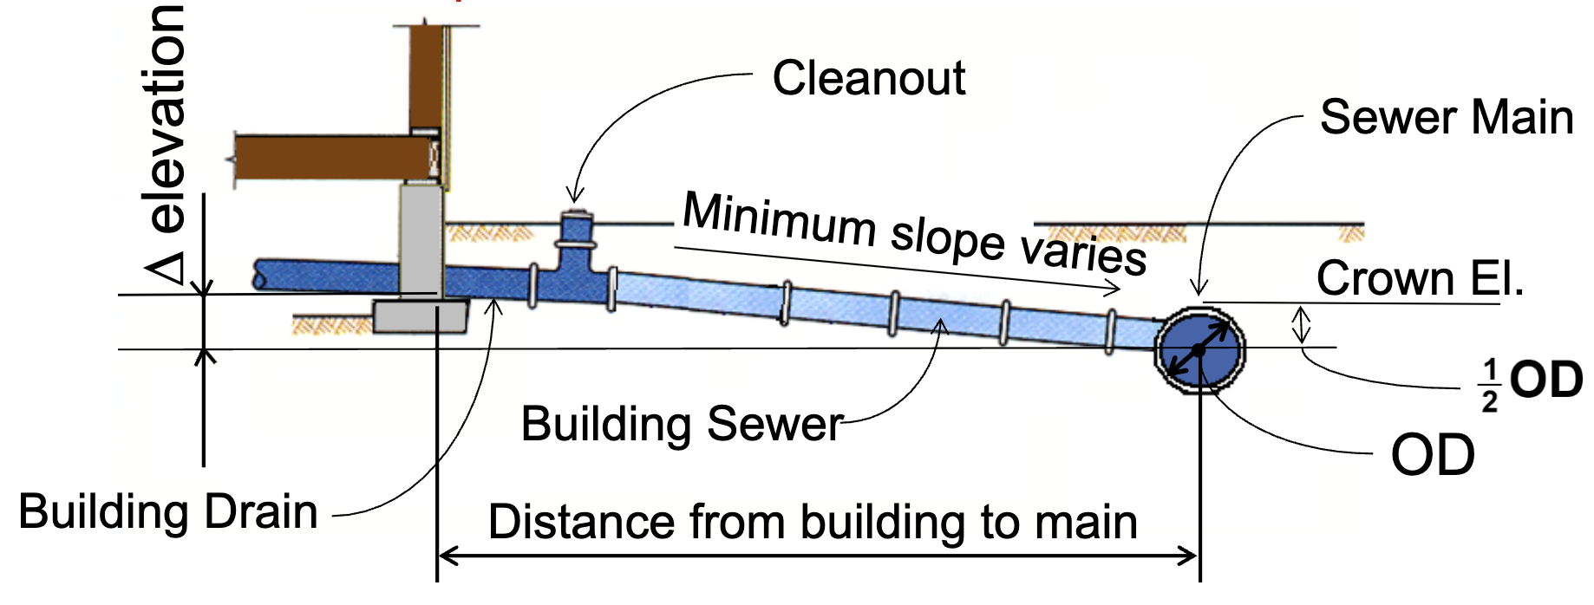
-Crown Elevation
Crown Elevation = Invert Elevation + Pipe Diameter
Crown Elevation = 766.05ft + 1ft
Crown Elevation = 767.05ft
-Distance from building to main = 123ft
-Slope
$$Sewer Lateral Slope= \frac{inv. El building-Crown EL+ \frac{1}{2}OD}{Distance}$$
$$Slope= \frac{778ft-767.05ft+(.5 × .5ft) }{416ft}*100$$
Slope = 2.6%
$\min{slope= }$0.2% (Reference IPC)

Framing

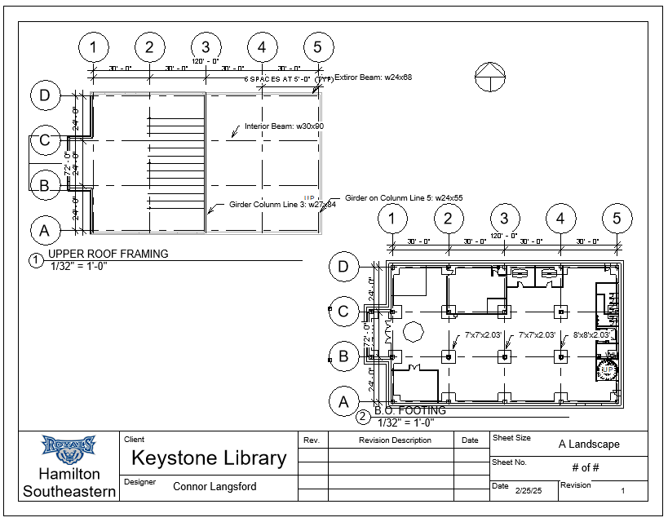
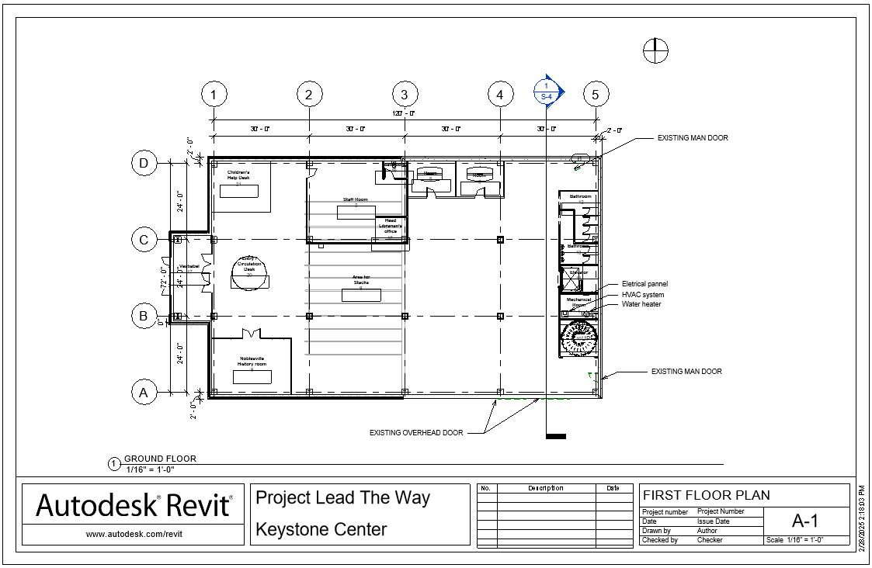
First Floor Plan
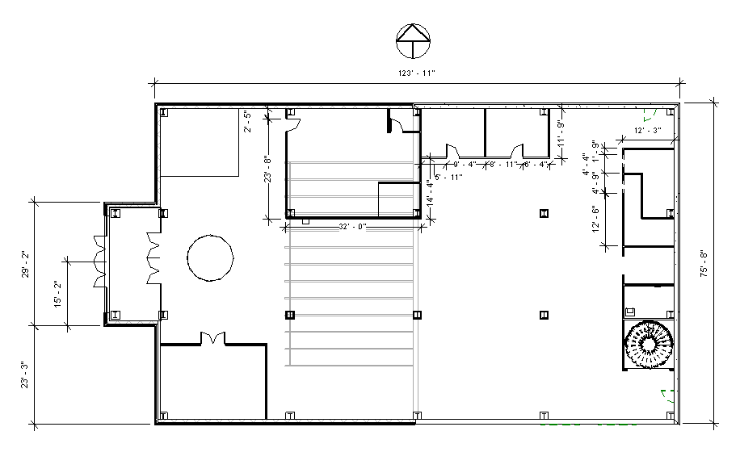
Second Floor Plan
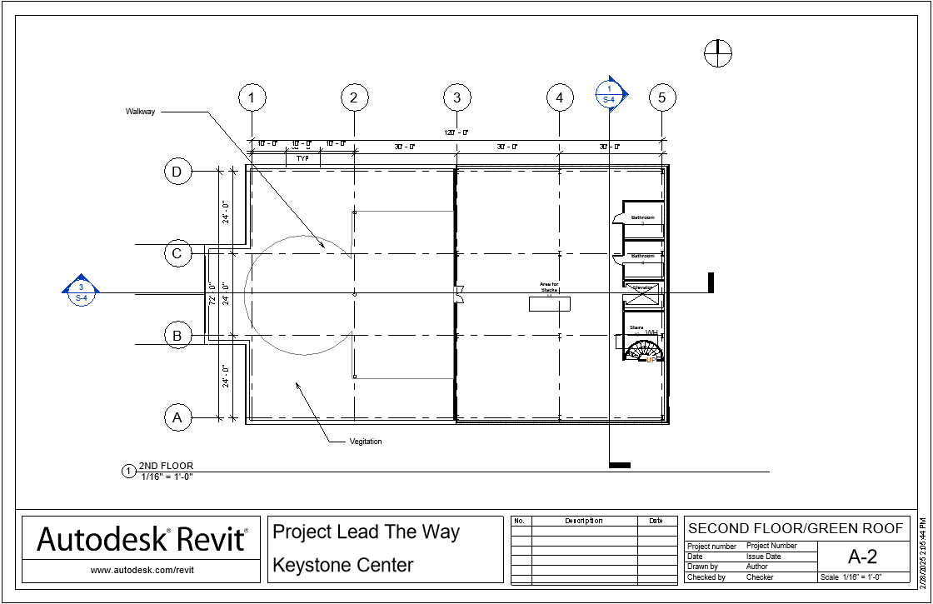
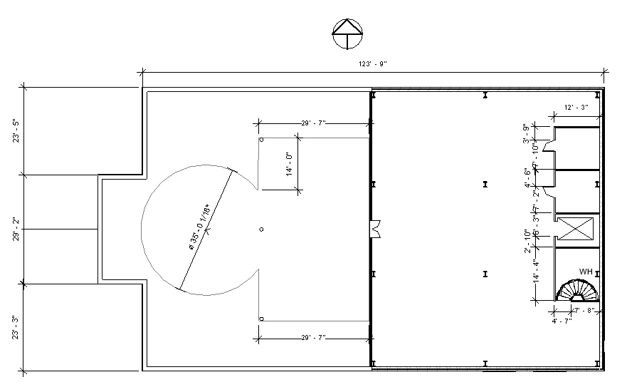
Elevation Views
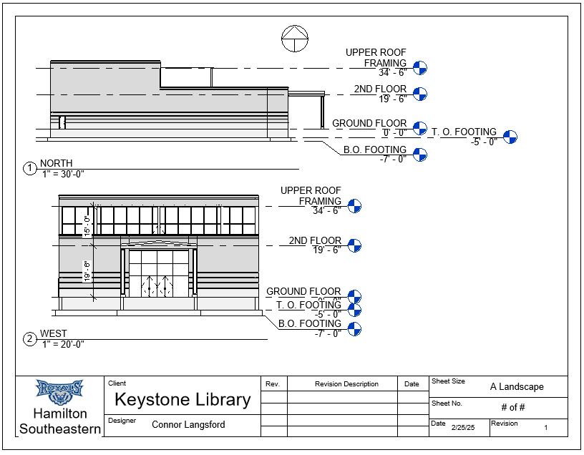
Section View
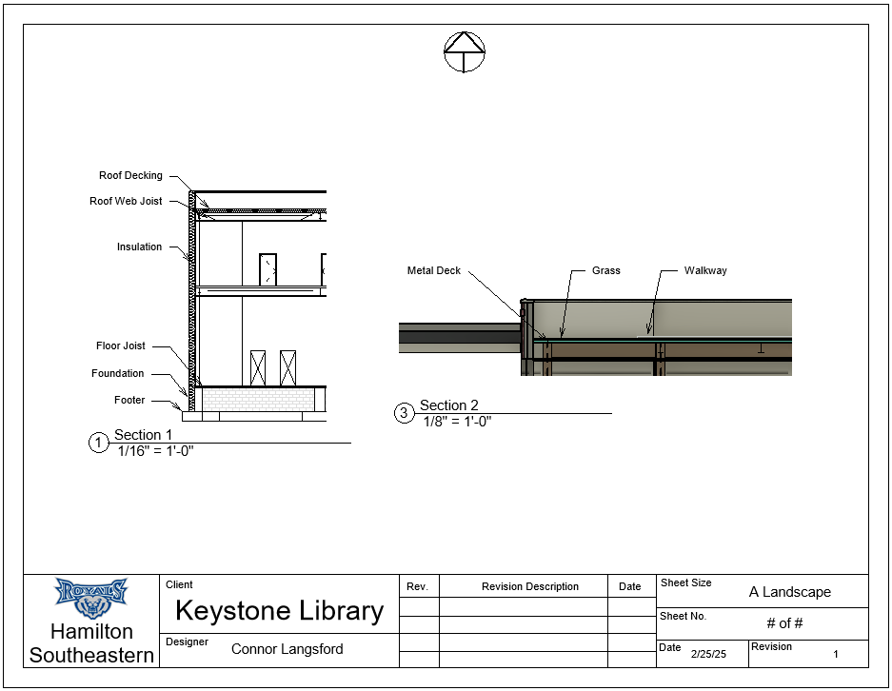
Landscaping
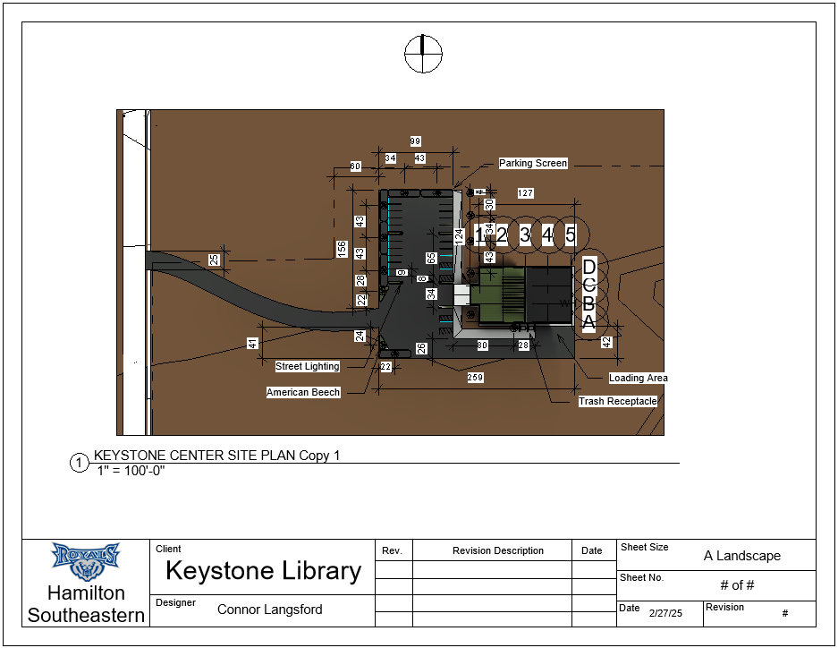
14 Evergreen 20’
Site Plan

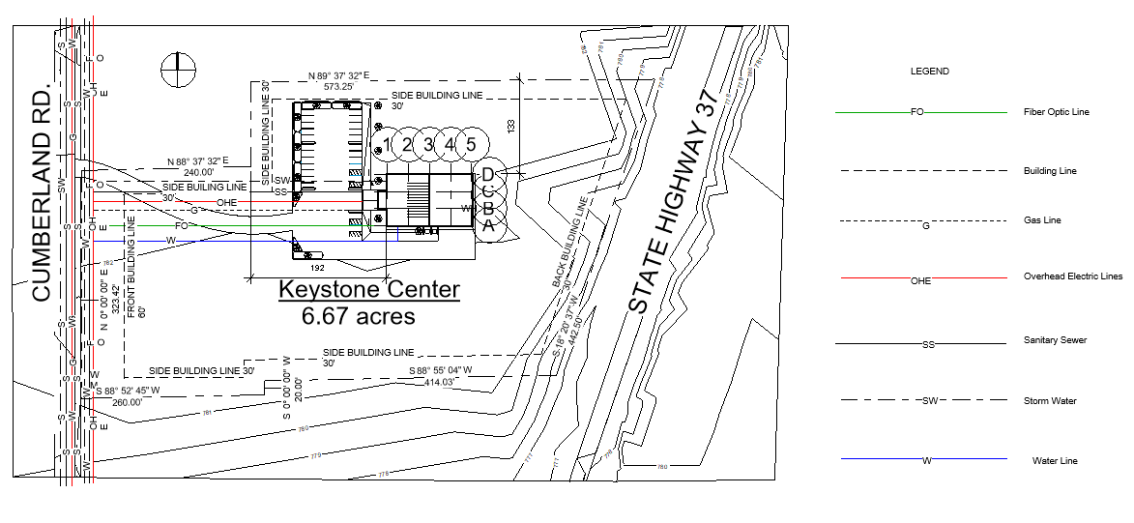
Schedules
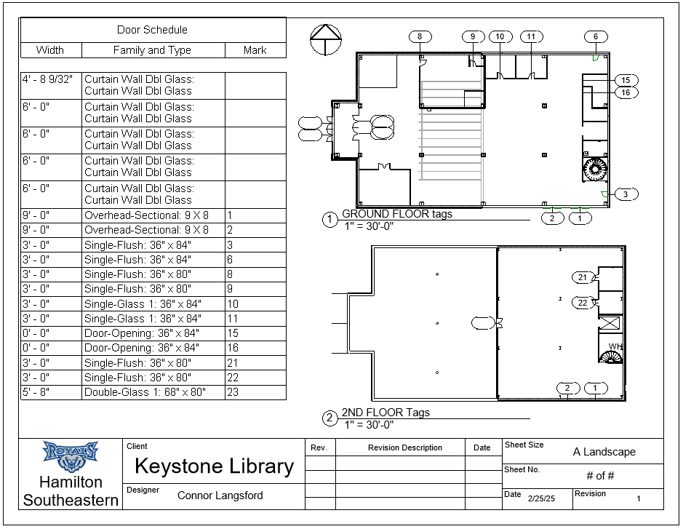
No windows (only curtain walls)

